Corrosion Science 20-03-2020

Introduction:
Metallic corrosion is a global Calamity of major importance and costs several million dollars every year. India loses a whopping Rs. 3,00,000 crores annually due to corrosion. Corrosion occurs with all metals except the least active noble metals such as Au, Pt etc., Most of the metals occur in nature in the form of ore. It is the stable state of metals. During extraction of metals, considerable amount of energy is required. Consequently, pure metals can be regarded as in excited state than the corresponding ores. When metals are exposed to corrosive environment, the exposed surfaces begin to decay i.e., converts into more stable metallic compounds (ore). Thus metallic corrosion is reverse process of metallurgy.
Q- What is metallic corrosion? Give examples. Explain two forms of corrosion
Corrosion may be defined as the destruction or loss of metals (and also alloys) by the surrounding environment through chemical or electrochemical reactions.
The process of corrosion in reality is the transformation of pure metal into its undesired metallic compound/s.
Ex: 1. Rusting of Iron – reddish brown scale formation on iron or steel is observed due to formation of rust (Fe₃O₄ or Fe₂O₃+FeO or hydrated Fe₃O₄)
2. Green scales formed on copper vessels due to the formation of basic cupric carbonate
[CuCO₃ + Cu(OH)₂].
3. Aluminium tarnishes (brightness decreases) due to formation of Al₂O₃ (alumina)

All metals undergo corrosion except gold and platinum, because they are more noble metals, passive
metals and have higher electrode potentials.

Corrosion may be: (two forms of corrosion)
i) Direct or chemical corrosion or dry corrosion.
ii) Electrochemical (Galvanic) corrosion or wet corrosion.

i) Dry or direct or chemical corrosion: This type of corrosion occurs mainly due to the direct chemical reaction between metal and the gases present in the environment. Here the corrosion product may be insoluble, soluble or a liquid.
ii) Wet or electrochemical corrosion: This is most common type of corrosion and it occurs when a conducting liquid is in contact with an aqueous solution. The conducting surface of the metal undergoes electrochemical reactions i.e., similar to reactions in Daniel cell.

Q- Why do the metals undergo corrosion?
Most of the metals, except the noble metals, occur in nature in the form of their compounds such as oxides, sulphides, carbonates, and chlorides etc. The metals are extracted from these ores by reduction. The extraction of metals from their ores is an endothermic reaction, energy being supplied in form of heat or electrical energy. Consequently pure metals will have relatively higher energy state and thermodynamically unstable compared to their corresponding ores and they have natural tendency to revert back to their combined state. Therefore when metals are exposed to atmosphere they combine with the constituents of the environment and get converted into their compounds (ores), called corrosion.
Hence the corrosion of metals can be considered as the reverse process of of metallurgy.
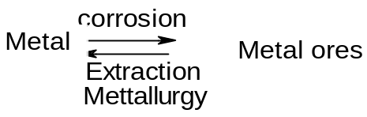

Metallurgists and chemists has been referred this corrosion as “cancer” to metals.
Corrosion damages
1. Poor appearance 2. Maintainace and operating cost 3. Plants shutdown 4. Contamination of products 5. Loss of valuable product due to the leakage. 6. Product liability
Q- Explain the mechanism of wet corrosion of iron by electrochemical theory with relevant reactions
According to electrochemical theory, corrosion of metals take place due to the formation of anodic and cathodic regions on the same or different surface or when two different metals are in contact with each other in the presence of a conducting medium.
When a metal such as iron is exposed to the environment, according to electrochemical theory the following 3 electrochemical changes occur.
- Formation of large number of minute galvanic cells (anodic and cathodic areas).
- Corrosion (oxidation) takes place at the anodic area.
- Reduction of oxygen in presence of water (moisture) to hydroxyl ions/H₂ at the cathodic area.

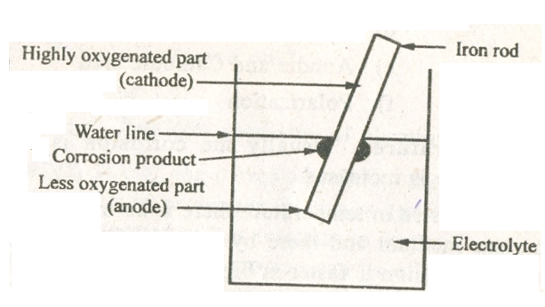
Corrosion reactions: The above 3 changes can be understood by considering the corrosion of iron rod, which is partially immersed in aerated NaCl solution. The are above the solution is well aerated and acts as cathode while the metal well inside the solution acts as anode and undergoes oxidation (corrosion)
Anodic reaction
At anodic area, oxidation takes place resulting in corrosion of iron
Fe (s) → Fe²⁺_{(aq)} + 2e⁻¹
Cathodic reactions
At the cathode, electrons flow from anodic area to cathodic area results in reduction of oxygen in presence of moisture to OH⁻ and H₂ gas
There are three ways by which reduction take place depending on the nature of corrosive environment.
- If the solution is aerated and neutral medium
2H₂O + O₂ + 4e⁻¹ → 4OH⁻
- If the solution is deaerated and neutral (alkaline medium)
2H₂O +2e⁻¹ → 2OH⁻¹ + H₂↑
- In acidic medium and in the absence of oxygen cathodic reaction is
2H⁺ + 2e⁻¹ → H₂↑
The metal ions formed at anode (Fe²⁺) combine with the OH⁻¹ ions liberated at cathode to form the corrosion product and it is accumulated at the junction of cathode and anodic area.
2Fe²⁺ + 4OH⁻¹ → 2Fe(OH)₂
4Fe(OH)₂ + O₂ + 2H₂O → 2[ Fe₂O₃.3H₂O]
Rust

Q- Discuss different types of corrosion
Types of corrosion: The following 3 types of corrosion have been observed on the basis of the nature of the galvanic cells.
    - Differential metal corrosion
    - Differential aeration corrosion
    - Stress corrosion
1. Differential metal corrosion: this type corrosion occurs when two dissimilar metals are in contact with each other in a corrosive conducting medium. The two metals differ in their tendencies to undergo oxidation, the one with lower electrode potential act as anode and the one with higher reduction potential act as cathode. The potential difference between the two metals is the cause for corrosion. Higher the potential difference faster is the rate of corrosion. The anodic meal undergoes corrosion. The following reactions occur during the galvanic corrosion.
At the anode (less noble metal): M → M^{n+} + ne⁻
At the cathode: depending on the corrosion environment the cathode reaction may be either hydrogen evolution or oxygen absorption.
(i). 2H⁺ + 2e⁻ → H₂ (g)
(ii). O₂ + 2H₂O + 4e⁻ → 4OH⁻
Examples: (i). Steel screws in copper sheets.
(ii). Steel pipe connected to copper plumbing.
(iii). Lead antimony solder around copper wire.
(iv) Iron bolt and copper nut
2. Differential aeration corrosion: Corrosion of metals arising as a result of an oxygen concentration cell due to uneven supply of air on a metal surface is known as differential aeration corrosion. Differential aeration corrosion occurs when a metal surface is exposed to differential air concen. or oxygen concentrations. The part of the metal exposed to higher concentration acts as cathode region and the part of the metal exposed to lower concentration act as anode.
At the anode (less oxygen concentration, oxidation): M → M^{n+} + ne⁻
At the cathode (more oxygen concentration, reduction): O₂ + 2H₂O + 4e⁻ → 4OH⁻
Examples - (i) Water line and (ii) Pitting corrosion.
(i) Water - line corrosion: This type of corrosion is observed commonly in storage tanks in which water is stored for longer period. The water line corrosion takes place due to the formation of differential oxygen concentration cells. The part of the metal below the water line is exposed only to dissolved oxygen while the part above the water is exposed to higher oxygen concentration of the atmosphere. Thus, part of the metal below the water acts as anode and undergoes corrosion and the part above the water line is free from corrosion. This type of corrosion is commonly observed ocean going ships, water storage steel tanks etc.
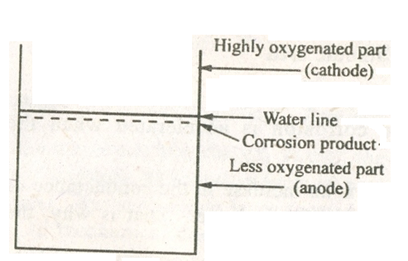
Water storage tank
(ii) Pitting corrb

osion: Pitting corrosion results when impurities like dust, scale, sand water drop etc deposited on the metal surface induces pitting corrosion. The portions covered by the dust will not well aerated compared to the exposed surface. The uneven oxygen concentration results in the formation of oxygen concentration cell. Thus covered portion becomes anode with respect to the exposed surface. In the presence of electrolytes or moisture, corrosion starts beneath the dust forming a pit. The formation pit (small anodic area) compared to exposed surface (cathodic area), increases the rate of the corrosion, hence pitting corrosion is most destructive type of corrosion.

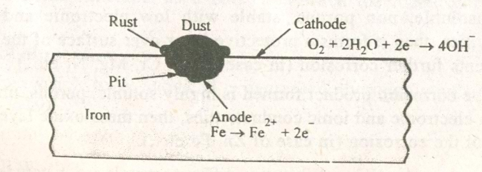
3. Stress corrosion: stress corrosion occurs in fabricated articles. In metals stress results due to welding, bending, pressing, quenching, rewetting etc. If the two metals, one of which is under stress, are placed in corrosive environment, the stress portion corrodes a faster rate. At stressed part, the atoms are some what displaced creating an anodic zone and undergoes corrosion. While unstressed part acts as cathode and it is protected. An example of stress corrosion is caustic embrittlement in boilers.

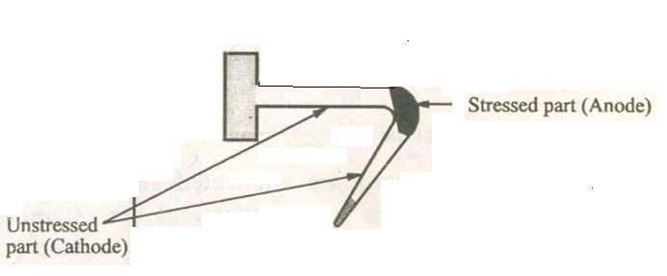
At anodic area, oxidation takes place resulting in corrosion of iron
Fe (s) → Fe²⁺_{(aq)} + 2e⁻¹
At the cathodic area, electron flow from anodic area to cathodic area results in reduction of oxygen in presence of moisture to OH⁻ and H₂ gas
2H₂O +2e⁻¹ → 2OH⁻¹ + H₂↑
Example for stress corrosion is caustic embrittlement.
Q-Write a note on caustic embrittlement.
Caustic embrittlement: it is a form of stress corrosion that takes place in boilers operating at high temperature and pressure, at the stressed regions of the boiler. The boiler feed water contains some sodium carbonate (Na₂CO₃) left behind during the softening process. At high pressure and temperature, the residual Na₂CO₃ undergoes hydrolysis producing sodium hydroxide and CO₂ and make water alkaline
Na₂CO₃ + H₂O → 2NaOH + CO₂
This alkaline water passes into the cracks, revetts, air cracks or stressed parts by capillary action. Water evaporates leaving behind caustic soda in the cracks. The concentration of NaOH when reaches a 10%, it attacks the metals (iron) at the stressed region, dissolving it in the form of sodium ferroate (Na₂FeO₂).
which undergoes hydrolysis depositing magnetite (Fe₃O₄).
6Na₂FeO₂ + 6H₂O + O2 -------- 2Fe₃O₄ + 12NaOH
The iron in contact with concentrated alkali, being under stress, becomes anode, while stress free iron surrounded by dilute alkali becomes cathode. Corrosion takes place at the stressed region. The corrosion cell can be represented as
Fe (under stress) / conc. NaOH / Fe (stress free)
Anode Cathode
Oxidation or corrosion Reduction
Caustic embrittlement can be prevented by the addition of compounds like sodium sulphite, tannin, lignin, phosphates etc. which blocks the cracks thereby preventing the infiltration of alkali. The continuation of caustic embrittlement of boiler parts results failure or boiler explosion.

Q. How does galvanic series different from electrochemical series?

Electrochemical series do not account for the corrosion behavior of all metals. Hence, another series called galvanic series, which provide more reliable information about the corrosion of not only metals but also alloys also. These series have prepared by studying the corrosion behavior of metals and alloys in a given environment like sea water. The difference between these 2 series has been summarized below:
Electrochemical series | Galvanic series
This series predicts the relative displacement tendencies of metals and non-metals in the electrolyte containing particular concentration (1M) of salt solutions of the same metal. | This series predicts the corrosion tendencies of metals and non-metals in actual environment.
It comprised metals and non - metals | It comprised metals and alloys
The position of a metals in this series is permanently fixed | The position of a given metal may shift in this series.
The electrode potential are measured by using standard hydrogen electrode | The electrode potential are measured by using saturated calomel electrode
It gives no information regarding position of alloys | The corrosion behavior of alloys can also be studies for their position in this series.

Q- Explain the various factors influencing the rate of corrosion:
Rate and extent of corrosion depends on the following 2 factors (i) Primary (ii) Secondary
(i) Primary factors: These factors are related to metal. The following factors are influence the rate of the corrosion
- Nature of the metal
- Nature of corrosion product or Inherent tendency of the metal to form protective films
- Hydrogen over voltage
- Electrode potential value
(1) Nature of the metal and surface state of the metal: The tendency to undergo corrosion is dependent on the nature of the metal. In general, the metals with lower electrode potential are more reactive than the metals with higher electrode potential values. The more reactive metals are more susceptible for corrosion. Thus the tendency of a metal to undergo corrosion decreases with increase in electrode potential. For example the active metals like Na, K, Zn with low electrode potential values are highly susceptible for corrosion, the noble metals such as silver, gold, platinum etc with higher electrode potential values are less susceptible for corrosion. The metal with smooth surface and high purity has less susceptible to corrosion.
(2) Inherent tendency of the metal to form protective films (the nature of corrosion product): A thin, invisible, impervious, continuous film forms in the form of oxides of the metal. The oxide layer determines the corrosion rate. If its composition is stoichiometric, highly insoluble, stable, uniform, and nonporous with low ionic and electronic conductivities, then the layer prevents (passive layer) further corrosion. For example in case of Al, Ti, Mg, Ni and Cr develops such layer on their surface and become passive to corrosion. If the oxide layer formed is non-stoichiometric, highly soluble, unstable , nonuniform and porous with high ionic and electronic conductivities, then the layer (active layer) does not prevents further corrosion. Example: Zn, Fe, Mg, Cd etc.
(3) Hydrogen over-voltage: is defined as the excess of voltage that has to be applied above the theoretical decomposition potential to start the continuous electrolysis. A metal with low hydrogen overvoltage is more susceptible for corrosion, when the cathodic reaction is hydrogen evolution type. With lower hydrogen overvoltage, hydrogen gas is liberated easily and thus the cathodic reaction rate is faster. This will make the anodic reaction also faster, thereby promoting overall corrosion reaction. When hydrogen overvoltage on the metal surface is high, cathodic reaction is slower and the corrosion of the metal also becomes slower.
(4) Electrode Potential: When 2 different metals are in contact with each other galvanic corrosion takes place. The larger the electrode potential (E⁰) difference between the anodic and cathodic region of the corrosion cell, higher is the corrosion rate. When the potential difference is more, higher corrosion current is produced and free energy decrease accompanying the process is higher and the corrosion rate is also higher. Therefore, when two different metals with larger difference in their electrode potential difference are in contact with each other, the more reactive metal undergoes corrosion very fast. For example potential difference between Fe and Cu is more than that between Fe and Sn, hence Fe corrodes faster in contact with Cu than with Sn. So use of dissimilar metals should be avoided whenever possible. (bolt, nut, screw, used should be made of same metal to avoid galvanic corrosion)
(ii) Secondary factors: These factors are related to environment
- pH
- Temperature
- Relative area of anode and cathode
- Conductance of medium
- Humidity of air
- Presence of impurities
- pH of the medium: The pH of the solution also decides the type of cathodic reaction and thereby influencing the corrosion rate. In general corrosion rate is high at high acidic medium than alkaline medium. If pH is greater than 10, the rate of corrosion of metals stops due to the formation of a protective coating of metal hydroxide. Between pH 8-3 presence of oxygen is essential for corrosion. If pH is less than 3, metals under go severe corrosion even in absence of oxygen.
(2) Temperature: usually the rate of corrosion reaction accelerated with the rise in temperature. The Corrosion rate (redox reaction) also increases as the temperature increases and also the diffusion of ions also increases. Because increase in temperature increases the conductance of the corrosion medium, also contribute to the increase in corrosion rate. In some cases temperature decreases the passivity, which again metals leads to increase in corrosion rate.
(3) Relative area of anode and cathode: The rate of corrosion is greatly influenced by the relative size of anodic and cathodic areas. Smaller the anodic area and larger the cathodic area faster is the rate of corrosion. Because the demand for electrons by a large cathodic area can be met by smaller anodic areas only by undergoing corrosion more briskly at smaller anodic area.
Small anodic area

v
Tin (Sn) plating (large cathodic area)
Fe (Anode)

Rapid corrosion, if anodic is less compare to cathodic area

Small cathodic area

Zn plating (large anodic area)
Zn plating Slow corrosion, if anode is more compare to cathode area
Fe (Cathode)

(4) Conductance of the medium: Conducting species in the corrosive medium increases the corrosion rate. Because corrosion is an electrochemical phenomenon which involves the transfer of electrons and ions. The rate of corrosion in a dry atmosphere is less than that in a wet atmosphere since the latter is more conducting.
(5) Humidity: is the deciding factor in atmospheric corrosion. At low relative humidity rate of corrosion is slow, as the humidity increases in the medium, the corrosion rate gradually increases. Metallic corrosion is very high above critical humidity. Critical humidity is defined as the relative humidity above which the corrosion of metals increases sharply. The value of Critical humidity depends on the physical characteristics of metals as well as the nature of corrosion product.

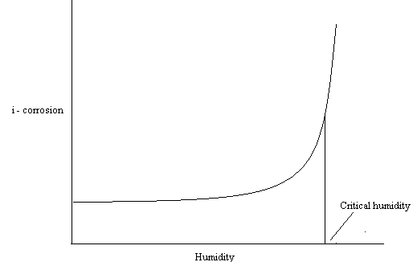

For example iron rust very slowly in an atmosphere with less than 60 % relative humidity, beyond this value iron rusts very fast
(6) Presence of chemicals in atmosphere: the impurities like SO₂, CO₂, NO_{x,} H₂S, fumes of HCl and H₂SO₄ increase the acidity of the medium and thereby increase the rate of corrosion.
SO₂: Corrosion of metals occurs in the presence of SO₂ at relatively high humidity. At concentration of 0.01% SO₂ and relative humidity of 50%, iron shows negligible corrosion even after 60 days, but at the same concentration of SO₂, at a relative humidity of 90% the sample will be completely covered by rust in one day. The combined effect of SO₂ and humidity is very corrosive to metals.
CO₂: Rate of corrosion of iron is found to decrease in the presence of carbon dioxide. The action of carbon dioxide is due to following two reasons
Carbon dioxide modifies the gel structure of rust making it less permeable to corrosion
Carbon dioxide forms an insoluble basic carbonate on the surface having more protective properties than the normal rust.
Fumes of HCl, H₂SO₄: The presence of HCl and H₂SO₄ and other acidic fumes in the atmosphere increases the acidic nature, higher the acidic nature of the environment higher is the rate of corrosion.
Corrosion control Methods:
The common methods used to control corrosion of metals are the following
1. Conversion coatings (anodizing and phosphating).
2. Inorganic metal coatings (a). Metal coatings – anodic (Galvanization) and cathodic (Tinning). 3. Protections: cathodic protection – Sacrificial anodic method
4. Corrosion inhibitors (anodic and cathodic)
1. Conversion coatings: Anodizing and phosphating are examples of conversion coatings.
Q- What is anodizing? Explain anodizing of aluminum.
(i) Anodizing: In case of Al, Zr, Ti etc., the corrosion product formed is usually the oxide of metal, which is protective in nature (passive to corrosion). But such oxide layer formed is very thin and less resistant to corrosion as well as mechanical damages. Therefore corrosion can be effectively decreased by increasing the thickness of the oxide layer over the surface of the metal by making the base metal as anode in some aqueous solution. This phenomenon is called anodizing. Anodizing can be defined as the process of developing a thick film of a passive metal oxide on the surface of a metal by electrochemical reaction.
Anodizing of aluminium:
Anodizing coating is generally produced on non-ferrous metals like Al, Mg and their alloys by anodic oxidation process in which the base metal is made as anode, It is carried out by passing direct electric current through a bath solution, in which the base metal is suspended. The most commonly used electrolyte is 10% H₂SO₄ or 10% chromic or oxalic acid, boric acid or their mixtures. The coating forms as a result of progressive oxidation and forms a thick layer of passive oxide film over the metal. This oxide film acts as a barrier between the metal and the environment.

Aluminum article to be anodized is degreased, thoroughly polished, washed with water and dried.
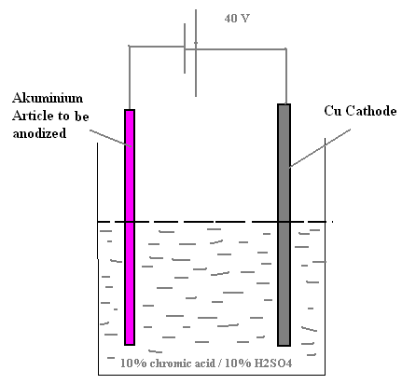

Anode – Aluminium article to be anodized
Cathode – Cu
Temperature – 35ºC
Voltage – 40V
Current density – 10-20 mA cm⁻²
Electrolyte – 10% chromic acid or 10% H₂SO₄

Electrode reactions:
At Anode:
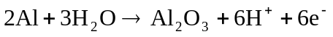
At Cathode:
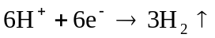
Overall reaction:
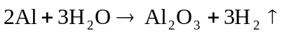
Applications: Anodized articles are used as soap box, window frames, tiffin carriers etc.

Q-Write a note on phosphating
ii. Phosphating: it is produced by the chemical or electrochemical reaction of base metal with aqueous solution of phosphoric acid and phosphate of a metal (Fe, Mn, Zn etc.,) along with an accelerator (copper salts). Phosphating is obtained on steel surface by converting the surface metal atoms into their phosphates by chemical or reaction. Modern phosphating bath solution contains a mixture of free phosphoric acid, a metal phosphate and an accelerator. An accelerator is used to speed up the reaction and reduce the crystal grain size. Nitrite accelerators are most widely used accelerators. The pH is maintained at about 7.8 to 3.2 and electrolysis carried out at a temperature 35 ⁰C. The metal forms phosphate in bath solution which subsequently gets deposited as in soluble phosphate on the surface of the metal.
The following steps involved in the phosphating process
(a). Dissolution of the metal as metal ion
(b). Metal ions retain with the phosphate ions to form a metal phosphate
(c) Deposition of the mixed metal phosphate on the surface of the metal.
Phosphate coating are usually applied by
i) Spraying
ii) Immersion
iii) Brushing
iv) Electrolysis

Q- What is metallic coating? How is a metal structure protected by metallic coating methods?
Metallic coatings: Deposition of a protective metal over the surface of a base metal is called metallic coating. Then coatings are basically applied on metal surfaces to control corrosion. Coatings prevent corrosion by acting as barrier and isolate the base metal surface from corroding environment. Metallic coatings are usually applied by electroplating, cladding, hot dipping, cementation, metal spraying electroless plating techniques. Based on the relative position of coating metal in emf series with respect to the base metal, the coatings are classified into two types.
i) Anodic metal coatings.
ii) Cathodic metal coatings.
(i) Anodic metal coatings: in these coatings more active metals are coated over the base metal articles. For examples iron article may be coated with metals which lie above it in the e.m.f. series like Zn, Al, Cd and Mg. The coatings are anodic to the base metal. During corrosion, the coating undergoes corrosion. Thus the base metal below the coating is protected.
Anodic metallic coating is safe and efficient even if the coating breaks at some places, the metal at these places do not undergo corrosion as it acts as cathode.
Galvanization: it is an example for anodic metallic coating in which Zn –metal is coated on an iron article. This process consists of the following steps.
1. The metal surface is washed with organic solvents to remove organic impurities on the surface.
2. Rust and other inorganic deposits are removed by washing with dilute sulphuric acid and rinsed with water.
3. The sheet is then treated with a mixture of aqueous solution of zinc chloride and ammonium chloride and dried (this helps in strong adherence of Zn on iron articles)
4. Then the dried sheet is dipped in molten zinc at 430 – 470⁰C.
5. The excess of zinc is removed by rolling, wiping or an air blast.
Galvanization process is used to protect iron from corrosion in the form of roofing sheets, fencing wires, barbed wire, bolts, nuts, nails, screws, pipes, tubes etc.
Galvanized articles are not used for preparing and storing food stuffs, since zinc dissolves in dilute acids producing toxic zinc compounds.
(ii) Cathodic coatings: The coatings which are cathodic to the base metal are called cathodic metal coatings. For example iron and steel are coated with high reduction metals like Cu, Ni, Sn, Cr, Ag etc., (which lie below the iron). Coated metal is less reactive than the base metal and convert the entire surface of base metal into cathode and resist corrosion. Cathodic coating should be free from breaks otherwise intense corrosion occurs due to large cathodic area and small anodic area.

Tinning: It is a familiar example for cathodic metal coating. In this method iron and steel are coated with tin metal. Tinning of iron or steel carried out by hot dipping method and the process involves following steps.
1. The metal surface is washed with organic solvents to remove grease and oil depositing
2. Rust and other deposits are removed by washing with dilute sulphuric acid and rinsing with water.
3. The sheet is then treated with a mixture of aqueous solution of zinc chloride and ammonium chloride and dried.
4. Then the dried sheet is passed a tank that containing molten tin.
5. The excess of tin is removed by a series of rollers immersed in palm oil.
Tinning is widely used for manufacturing containers used for storing food stuffs such as jam, pickles, instant food, milk products etc.
Q- Distinguish anodic and cathodic metal coatings
Anodic metal coatings | Cathodic metal coatings
i) Coating metals are anodic to base metal.  ii) Electrode potential of coating metal is lower than that of the base metal.  iii) Anodic coating is, if any break or discontinuities occur in such a coating, the base metal is not corroded, till all the coating metal is consumed.  iv) Coating of Zn on iron is an example. | i) Coating metals are cathodic to the base metal.  ii) Electrode potential of coating metal is higher than that of the base metal.  iii) It is unsafe, if any break or discontinuities occur in such a coating, the intense corrosion of base metal takes place because of large cathodic area and small anodic area.  iv) Coating of Sn on iron is an example.

Q-What is cathodic protection? Discuss sacrificial anode method of prevention of corrosion
Cathodic protection: Cathodic protection is a method of protecting a metal or alloy from corrosion by converting it completely into cathodic and no part of it is allowed to act as anode. Corrosion of a specimen occurs primarily because of the flow electrons from anodic to cathodic regions. This can be prevented by providing electrons from an external source, so that the specimen remains always cathodic. This technique is called cathodic protection or galvanic protection.
Cathodic protection can be provided by sacrificial anode method
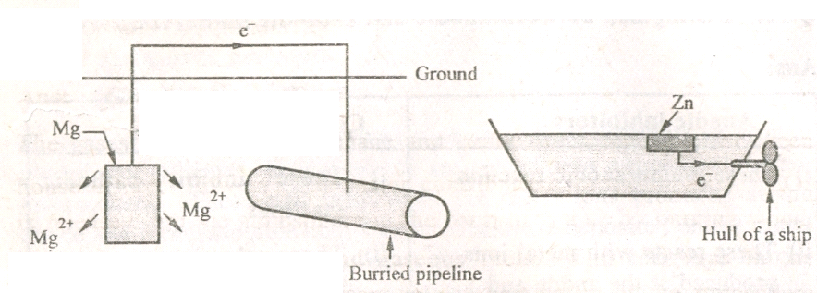
Sacrificial anodic method protection:. In this method, the protected structure is converted into a cathode by connecting it to a more active metal. This is active metal act as auxiliary anode. Zn, Mg, Al are he common auxiliary anodes used in this method. These metals being more active acts as anode and under go preferential corrosion, protecting the metal structure. Since anodic metals are sacrificed to protect the metal structure, hence this method is known as sacrificial anodic method.

Ex: 1. Magnesium block connected to a buried oil storage tank
2. Zinc bars are fixed to the sides of ocean going ships to act as sacrificial anodes.
Advantages: 1.The method is simple 2. Low installation cost. 3. Minimum maintenance 4. Not require power supply.
Q-Explain how corrosion is controlled by using anodic and cathodic inhibitors with suitable
examples and reactions.
Corrosion inhibitors: The rate corrosion is reduced by the use of certain chemicals are added directly to corrosive medium to decrease the rate of corrosion called inhibitors. Inhibitors slow down the anodic and cathodic reactions occurring in the corrosion process by forming a protective film over anodic or cathodic area. On the basis of this property, corrosion inhibitors are classified as anodic and cathodic corrosion inhibitors.
Anodic corrosion inhibitors: oxidation of the metal is the reaction ocures at anodic region during corrosion. For example- in rusting of iron, Fe²⁺ ions are formed at anodic region. If the formation of Fe²⁺ is prevented, the oxidation reaction stops and there by corrosion process retarded. This is achieved by the addition of inhibitors such as sodium chromates, molybdates, tungstates, and nitrite. These ions combine with metal ions form a thin protective layer of coating and thus decrease the rate of anode reaction. Non oxidizing agents include phosphates, borates, silicates and benzoates. These forms less soluble compounds and form a protective oxide film over the anodic surface.
Anodic inhibitors are found to be effective only when they are added in sufficient quantity. When insufficient amount is added, the situation is more disastrous than not adding at all. This is because of the fact that insufficient quantity of inhibitors can not cover the entire anodic surface with protective film and leads to small anodic area and large cathodic area and thereby severe corrosion occurs.
Cathodic corrosion inhibitors: These are act by inhibiting the cathodic reactions which involves the liberation of hydrogen in acidic solution and hydroxyl ions in alkaline and near neutral solution. The cathodic reactions depending on the nature of corrosive environment.

a) In acidic medium: In acidic solutions, the main cathodic reaction is evolution of hydrogen.
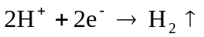
This cathodic reaction may be reduced by inhibiting the diffusion of H⁺ ions of cathode. Organic inhibitors such as amines, urea, thiourea, heterocyclic compounds are widely used as cathodic inhibitors. These are adsorbed on the cathodic surface and there by prevent the diffusion of H⁺ ions. They also reduce the acidity and thereby reduce the rate of corrosion.
b) In neutral medium: In neutral solutions, the cathodic reaction is:
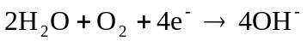
Corrosion can be controlled either by eliminating oxygen from the corroding medium or by retarding its diffusion to the cathodic areas.
Addition of sodium sulphite, hydrazine removes oxygen from corrosive medium.
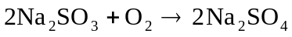

Inhibitors like Mg, Ni or Zn salts are added directly in to the corrosive medium. The cataions of the salts migrate towards the cathode surface and reacts with the cathodically formed hydroxyl ions forming insoluble hydroxides which deposit on the cathode and prevent the access of O₂ to the cathode.
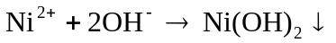

Q- Distinguish anodic and cathodic inhibitors

Anodic inhibitors | Cathodic inhibitors
i) These inhibit anodic reaction.  ii) These reacts with metal ions produced at the anode and form insoluble protective film on the anodic area.  iii) These are added in excess. It may be dangerous if certain regions on the metal are left unprotected by the depletion of inhibitor. There may be formation of small anodic areas and large cathodic areas which favour severe corrosion. | i) These inhibit cathodic reactions.  ii) These eliminate oxygen or reacts with hydroxyl ions liberated at cathode forming insoluble hydroxide film on the cathodic area.  iii) These are added in small quantities. Even the use of insufficient concentration of these substances does not have any adverse effect.

Question Bank on Corrosion
1. Explain the mechanism of wet corrosion of iron by electrochemical theory with relevant reactions.
2. Define metallic corrosion? Discuss the following factors which are influences the rate of
corrosion. (i) Nature of the metal and surface state of the metal (ii) Hydrogen over voltage
(iii) Inherent tendency of the metal to form protective films
3. Define metallic corrosion? Discuss the following factors which are influences the rate of
corrosion. (i) pH of the medium (ii) Relative areas of anode and cathode,
4. Discuss differential aeration corrosion with a suitable example. 5. Discuss stress corrosion by taking a suitable example.
6. What is anodizing? Explain anodizing of aluminum.
7. Write a note on caustic embrittlement.
8. Explain differential metal corrosion with suitable example.
9. Explain: (i) Ship sailing in water corrode below water line
(ii) Copper bolt should not be used in contact with aluminium.
(iii) Aluminium articles are self protected against corrosion while iron articles are not.
- Iron corrodes faster when in contact with copper but corrodes slowly when in contact with tin
(v) Zinc in contact with silver undergoes corrosion faster than Zinc in contact with copper.
(vi) Though aluminium is with lower electrode potential than iron it has higher corrosion
resistance than iron in oxidizing environments.
(vii) Iron bolts in copper vessel are undesirable.
(viii). Even if the zinc coating on iron is discontinuous, iron is free from corrosion.
(ix) Ocean going ships suffer differential aeration corrosion, but ships sunk under sea do not.
(x) Part of nail inside the wooden frame undergoes corrosion but the exposed area does not.
10. How is a metal structure protected by cathodic/anodic metal coating method?
11. Explain what type of corrosion occurs when (i) Screw and washer are made of different metals
(ii) Presence of NaOH in mild steel boiler under stress.
12. Discuss the following corrosion control methods i) Galvanizing (ii) Tinning 13. Write a note on phosphating
14. What is cathodic protection? Discuss sacrificial anode method of prevention of corrosion.
15. Explain how corrosion is controlled by using anodic and cathodic inhibitors with suitable
example and reactions.

